THE STAINED GLASS MUSEUM
Study Tour – Shrewsbury & Shropshire

Thursday 20 - Sunday 23 April 2023

Dates
Midday on Thursday 20 April – after breakfast Sunday 23 April 2023.*
*Visits will formally conclude on the evening of Saturday 23 April, although the cost of the weekend includes dinner and accommodation for Saturday night, and breakfast on Sunday morning.

Programme
Shropshire is a delightful county with much to offer the stained glass enthusiast. The prominent towns of Shrewsbury in the north and Ludlow in the south contain some of the most interesting and important stained glass of the medieval period. David Evans, one of the most talented artists of the early 19th century, produced much stained glass in partnership with John Betton of Shrewsbury. Betton & Evans were pioneers in the early gothic revival producing windows in both pictorial and transitional gothic styles and we will see several examples of their work. In addition, the county boasts lesser well-known examples of the work of 20th century artists such as Margaret Rope (Shrewsbury and Newport), Louis Davies, and Thomas Early of Dublin (Ludlow) amongst others. Over the course of three days we will visit more than 15 sites.
Fitness: You will need to be fit enough to get on and off a coach and undertake some walking. Given the size of Shrewsbury and proximity of sites, one day will be spent on foot in the town. The total area covered over the course of the day will not exceed more than 3-4 miles in total, and the longest stretch will be 10-15 minutes max (0.5 miles).

Accommodation
We will be staying at the Mercure Shrewsbury Albrighton Hall Hotel & Spa, north of Shrewsbury. Albrighton Hall is an 18th century former manor house nestled in 15 acres of grounds with an ornamental lake. Parking is available on site, and guests have complimentary internet access and TV in their rooms. Guests are also able to use the hotel’s leisure facilities including indoor heated pool, sauna, steam and ice room.

Guides
The 2023 Study Tour will be primarily guided by Dr Jasmine Allen (Director & Curator, The Stained Glass Museum.

Prices (per person)
The Stained Glass Museum,
The South Triforium,
Ely Cathedral, Ely,
CB7 4DL.
Tel: 01353 660347

events@stainedglassmuseum.com
www.stainedglassmuseum.com

Residential:
£500 Residential single occupancy
(inc. three nights bed & breakfast & evening meals)
£450 Residential double/twin occupancy
(inc. three nights bed & breakfast & evening meals)
Non-residential:
Please note Residential places have priority booking
£250 Non-Residential (visits only) PLACES LIMITED

All prices include: two and a half days guided visits by coach, plus accommodation, breakfast and dinner for three nights, entrance fees to sites (where applicable), and a conference pack with site notes.

Insurance & Liability
We recommend that you take out your own travel insurance. The museum has Public Liability Insurance and carries out a full risk assessment for its Study Tours, but many of the sites we visit due to their age have uneven floors and other hazards. We are not responsible for any trips or falls that take place off the museum premises.

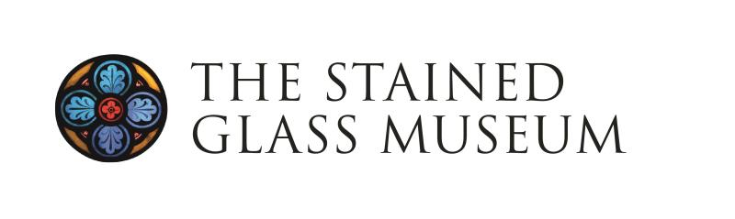
Student/Graduate Bursary Information - Study Tour
Shrewsbury & Shropshire, 20-23 April 2023
Application Deadline: Friday 24 February 2023
About The Stained Glass Museum
The Stained Glass Museum is a small independent museum based in Ely Cathedral. Its national significant collection of stained glass spans from the 13th to the 21st centuries. www.stainedglassmuseum.com

Supporting Students
The Stained Glass Museum wishes to encourage students and recent graduates with a particular interest in stained glass to take part in its events, in order to extend their knowledge and experience and strengthen their links with the Museum.

In 2023, we are delighted to invite applications for one student/graduate bursary place to enable a student/graduate to attend the Study Tour to be held in Shrewsbury & Shropshire, 20-23 April 2023. This bursary has been made available thanks to the generosity of individual Friends of the Stained Glass Museum.

Eligibility
You must be (a) currently registered in full or part-time study or (b) have completed a programme of study within the last two years to be eligible for the Study Tour Bursary. The bursary is aimed at those whose practical or academic studies are related (directly or indirectly) in some way to the art of stained glass, its history or conservation. Applicants will need to make sure that attending the Study Tour 20-23 April 2023 will not conflict with other work or academic commitments and, if necessary, gain permission to attend from their tutor/supervisor.

Details of the Bursary
The bursary covers a substantial proportion of the costs of attending the study tour including hotel accommodation, breakfast and dinner, but the successful applicant will need to fund and arrange their own travel to and from our hotel north of Shrewsbury, where we will be based, and lunches are not provided. A condition of accepting the grant is for the successful applicant to provide a short article for the Museum’s bi-annual Friends Newsletter describing the trip.

Application Deadline
Friday 24 February 2023, 5pm

How to Apply
Applicants should apply using the simple form below, explaining how the 2023 Study Tour will help to develop their skills and knowledge, in relation to their programme of study and/or future ambitions (not more than 500 words).

Please submit a short CV together with your application.

The form and the CV should be sent to Dr Jasmine Allen, Director and Curator, by email curator@stainedglassmuseum.com or post to the address below, by 5pm on Friday 24 February 2023.

The Stained Glass Museum Study Weekend
Student Bursary Application Form
Shrewsbury & Shropshire, 20-23 April 2023
Contact Information
Name:
Email:
Address:
Contact No:

Details of your current (or most recent) Programme of Study
Title of your Course:
Institution/Place of Study:
Name of Supervisor/Tutor:
Course Start date: Course End date:

Application (no more than 500 words)

Please submit your application and C.V. by 5pm on Friday 24 February 2023

Dr Jasmine Allen
Director and Curator
The Stained Glass Museum
South Triforium
Ely Cathedral
Ely
CB7 4DL

Email: curator@stainedglassmuseum.com

